Premium quality charcoal for barbeque and grill

Followings are details of the production of sawdust charcoal at our charcoal factory. The manufacturing process (called “Hot Process), and the charring (carbonization) process using modified “Iwate” kiln are briefly explained.
Sawdust collected directly from sawing machine is used a principal raw material. The quality and performance of the produced charcoal is, thus, superior to traditional briquettes charcoal, which is generally produced from a mixture of flour, water and grinded ordinary wood charcoal. The whole process is closely monitored and controlled to achieve best product quality for export.

1. Raw material (sawdust) source for charcoal production
The sawdust collected directly from sawing machine is used as a principal raw material for the production of charcoal. The benefits of using sawdust are the homogeneity and cleanliness of the raw material, resulted in better consistency and superior performance of the final charcoal.
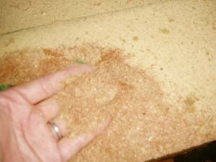
Before feeding to the extrusion process, the sawdust must be dried to reduce the moisture content for better quality of the charcoal.

2. Transportation of sawdust to the extruder
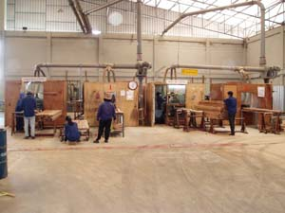
As shown in picture, the sawdust collected from sawing machine is pneumatically transferred into sawdust silo, which reduces the change of contamination of foreign materials.

3. High power extrusion machine
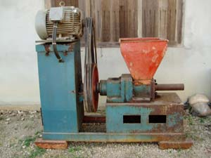
The high performance industrial extruders are specially designed to impose high pressure for higher density of the final product. This kind of extruder differs from traditional extruders for both performance (resulted in higher density of final density) and capacity.
4. Charcoal Manufacturing Kiln; “Iwate”
Charcoal manufacturing kiln is constructed based on Japanese “Iwate kiln” design for enhanced product quality with wood vinegar as a valuable by-product.
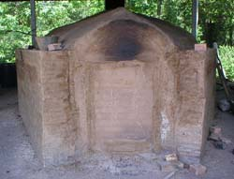
This Japanese “Iwate kiln” design & technology is supported by Royal Forest Department of Thailand. This type of kiln is superior to other traditional kiln because of the better heat distribution in the kiln, thus, giving better charcoal quality.

5. High quality charcoal from 100% sawdust without any additives
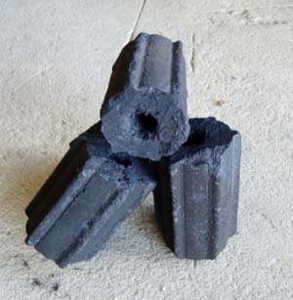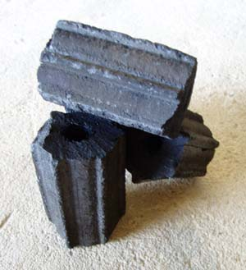
The product will be cut into desired length and packed into corrugated carton box or other packaging; e.g. sack. The final product will be randomly sampled and tested for heating value and other parameters to ensure the consistency of product quality.

